**P.S. 242 Kindergarten School Supplies**

(Please send these school supplies to school with your child on the first day of school!)

***All students should bring the following:***

___ 1 backpack (big enough to fit a folder… no wheels, please!)

___ 1 reusable water bottle (labeled with your child’s name)

___ A change of clothes (in case of accidents- underwear, socks, pants &

shirt. Put it in a zip-lock bag labeled **with your child’s name**.)

___ 1 box of Zip-lock GALLON SIZE Freezer Bags

___ 1 box of tissues

___ 2 rolls of paper towels (Bounty select-a-size, if possible!)

___ 1 large container of Clorox Disinfecting Wipes

___ 1 package of unscented baby wipes (Target, Huggies, Pampers, etc.)

___ Headphones with microphone that are compatible with our devices

Recommended: Avid AE-36 Headset with Adjustable Boom Microphone

<https://www.amazon.com/Avid-Adjustable-Microphone-Classroom-Assessment/dp/B00L2JUJ68?th=1>

|  | [Avid AE-36 Headset in White with Adjustable Boom Microphone for School, Classroom, Education, Testing and Assessment](https://www.amazon.com/Avid-Adjustable-Microphone-Classroom-Assessment/dp/B00L2JUJ68?th=1)  About this item . AVID EDUCATION AE-36 CLASSROOM HEADSETS - The perfect headset match for use with devices with a single 3.5mm headphone jack that operates both the speakers and microphone, such as some tablet computers and newer laptops  www.amazon.com |
| --- | --- |

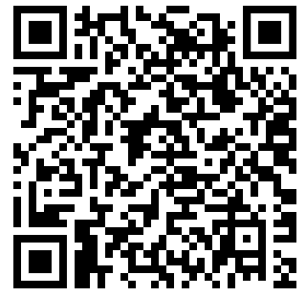

*All other items will be provided by the school! **THANK YOU** ☺