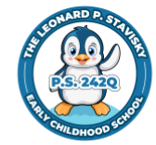 **P.S. 242**

**Leonard P. Stavisky**

**Early Childhood School**

29-66 137th Street

Flushing, NY 11354

(718) 445-2902

Jill Pritchard, Principal

Jennifer Krauss, Assistant Principal

Marguerite Choudhry, Parent Coordinator

***************************************

Come Join Our Family!

The application for kindergarten opens on December 10, 2024.

**Open House dates**

**Tuesday, December 10, 2024, 9:00 a.m.**

**Monday, January 6, 2025, 9:00 a.m.**

Open House Information:

All adult visitors must have photo ID.

Visit our website or stop in for information about our school!

[www.ps242q.org](http://www.ps242q.org)

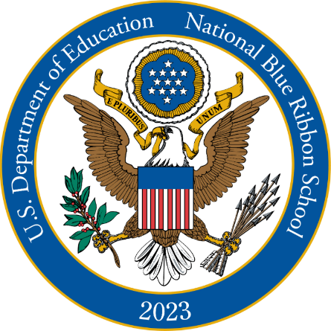

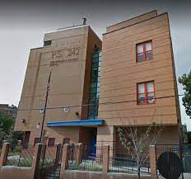

* 2016 and 2023 National Blue Ribbon School with high academic performance
* Nurturing early childhood approach
* Mandarin/English bilingual Kindergarten class available
* Outstanding family-school partnerships
* Interactive Whiteboards in every classroom.
* State of the Art outdoor playground with weather coverage
* Kids Leadership Team
* Clubs: STEM, Sports, Dance, Gardening, Art, and more!
* In-house Afterschool Program
* Busing available to those who qualify