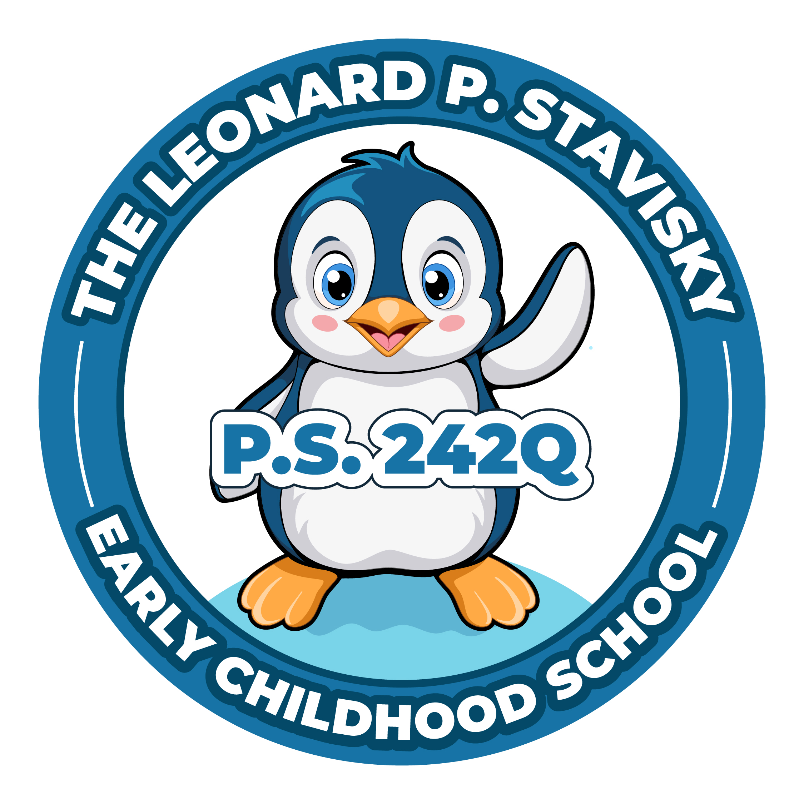
The Leonard P. Stavisky Early Childhood School
29-66 137th Street, Flushing, NY 11354
Phone: 718.445.2902 Fax: 718.939.7751

PTA MEETING--Wednesday, October 11, 2023
Meeting called to Order @ 6:05pm
Approval of Minutes- Record of the minutes approved.

Presidents Report - Chavaughn
- Survey was done to see if meetings will be in person or virtual.
Results were for virtual.
- Vote was taken to change bylaws in favor of virtual meetings.
Bylaws change was approved.
- A google form is being sent out for a volunteer list for this year’s events.
- Fall picture day is October 17th.
Class pictures will be taken including all children; individual pictures will be done for those who pay for them.
- Fall book fair is the week of October 23rd.
Info for setting up e-Wallets to the fair will be sent out.
- Costume parade/pumpkin patch is Halloween.
A schedule will be sent out letting you know what time your child’s class will be coming out.
Goodie bags will be given out.
- Fall Festival is November 4th.
More information to follow.
- The school store will go live soon with clothing featuring our new logo.

Treasurers Report - Afeesat
- Current balance in bank account is $6,479.83.
Unable to pull report up.
- Poll taken to approve Fall Festival budget of $1,800.
Approved.
- Poll taken to approve Pumpkin Patch/Halloween Goodie bags budget of $800.
Approved.

Principal’s Report given in separate meeting, Ms. Jill was unable to access meeting.
New Business
- Xiao asked how to make the school go up to 5th grade.
- New meeting link and code posted for Principal’s report.

Meeting adjourned at 6:18pm.

