The Leonard P. Stavisky Early Childhood School
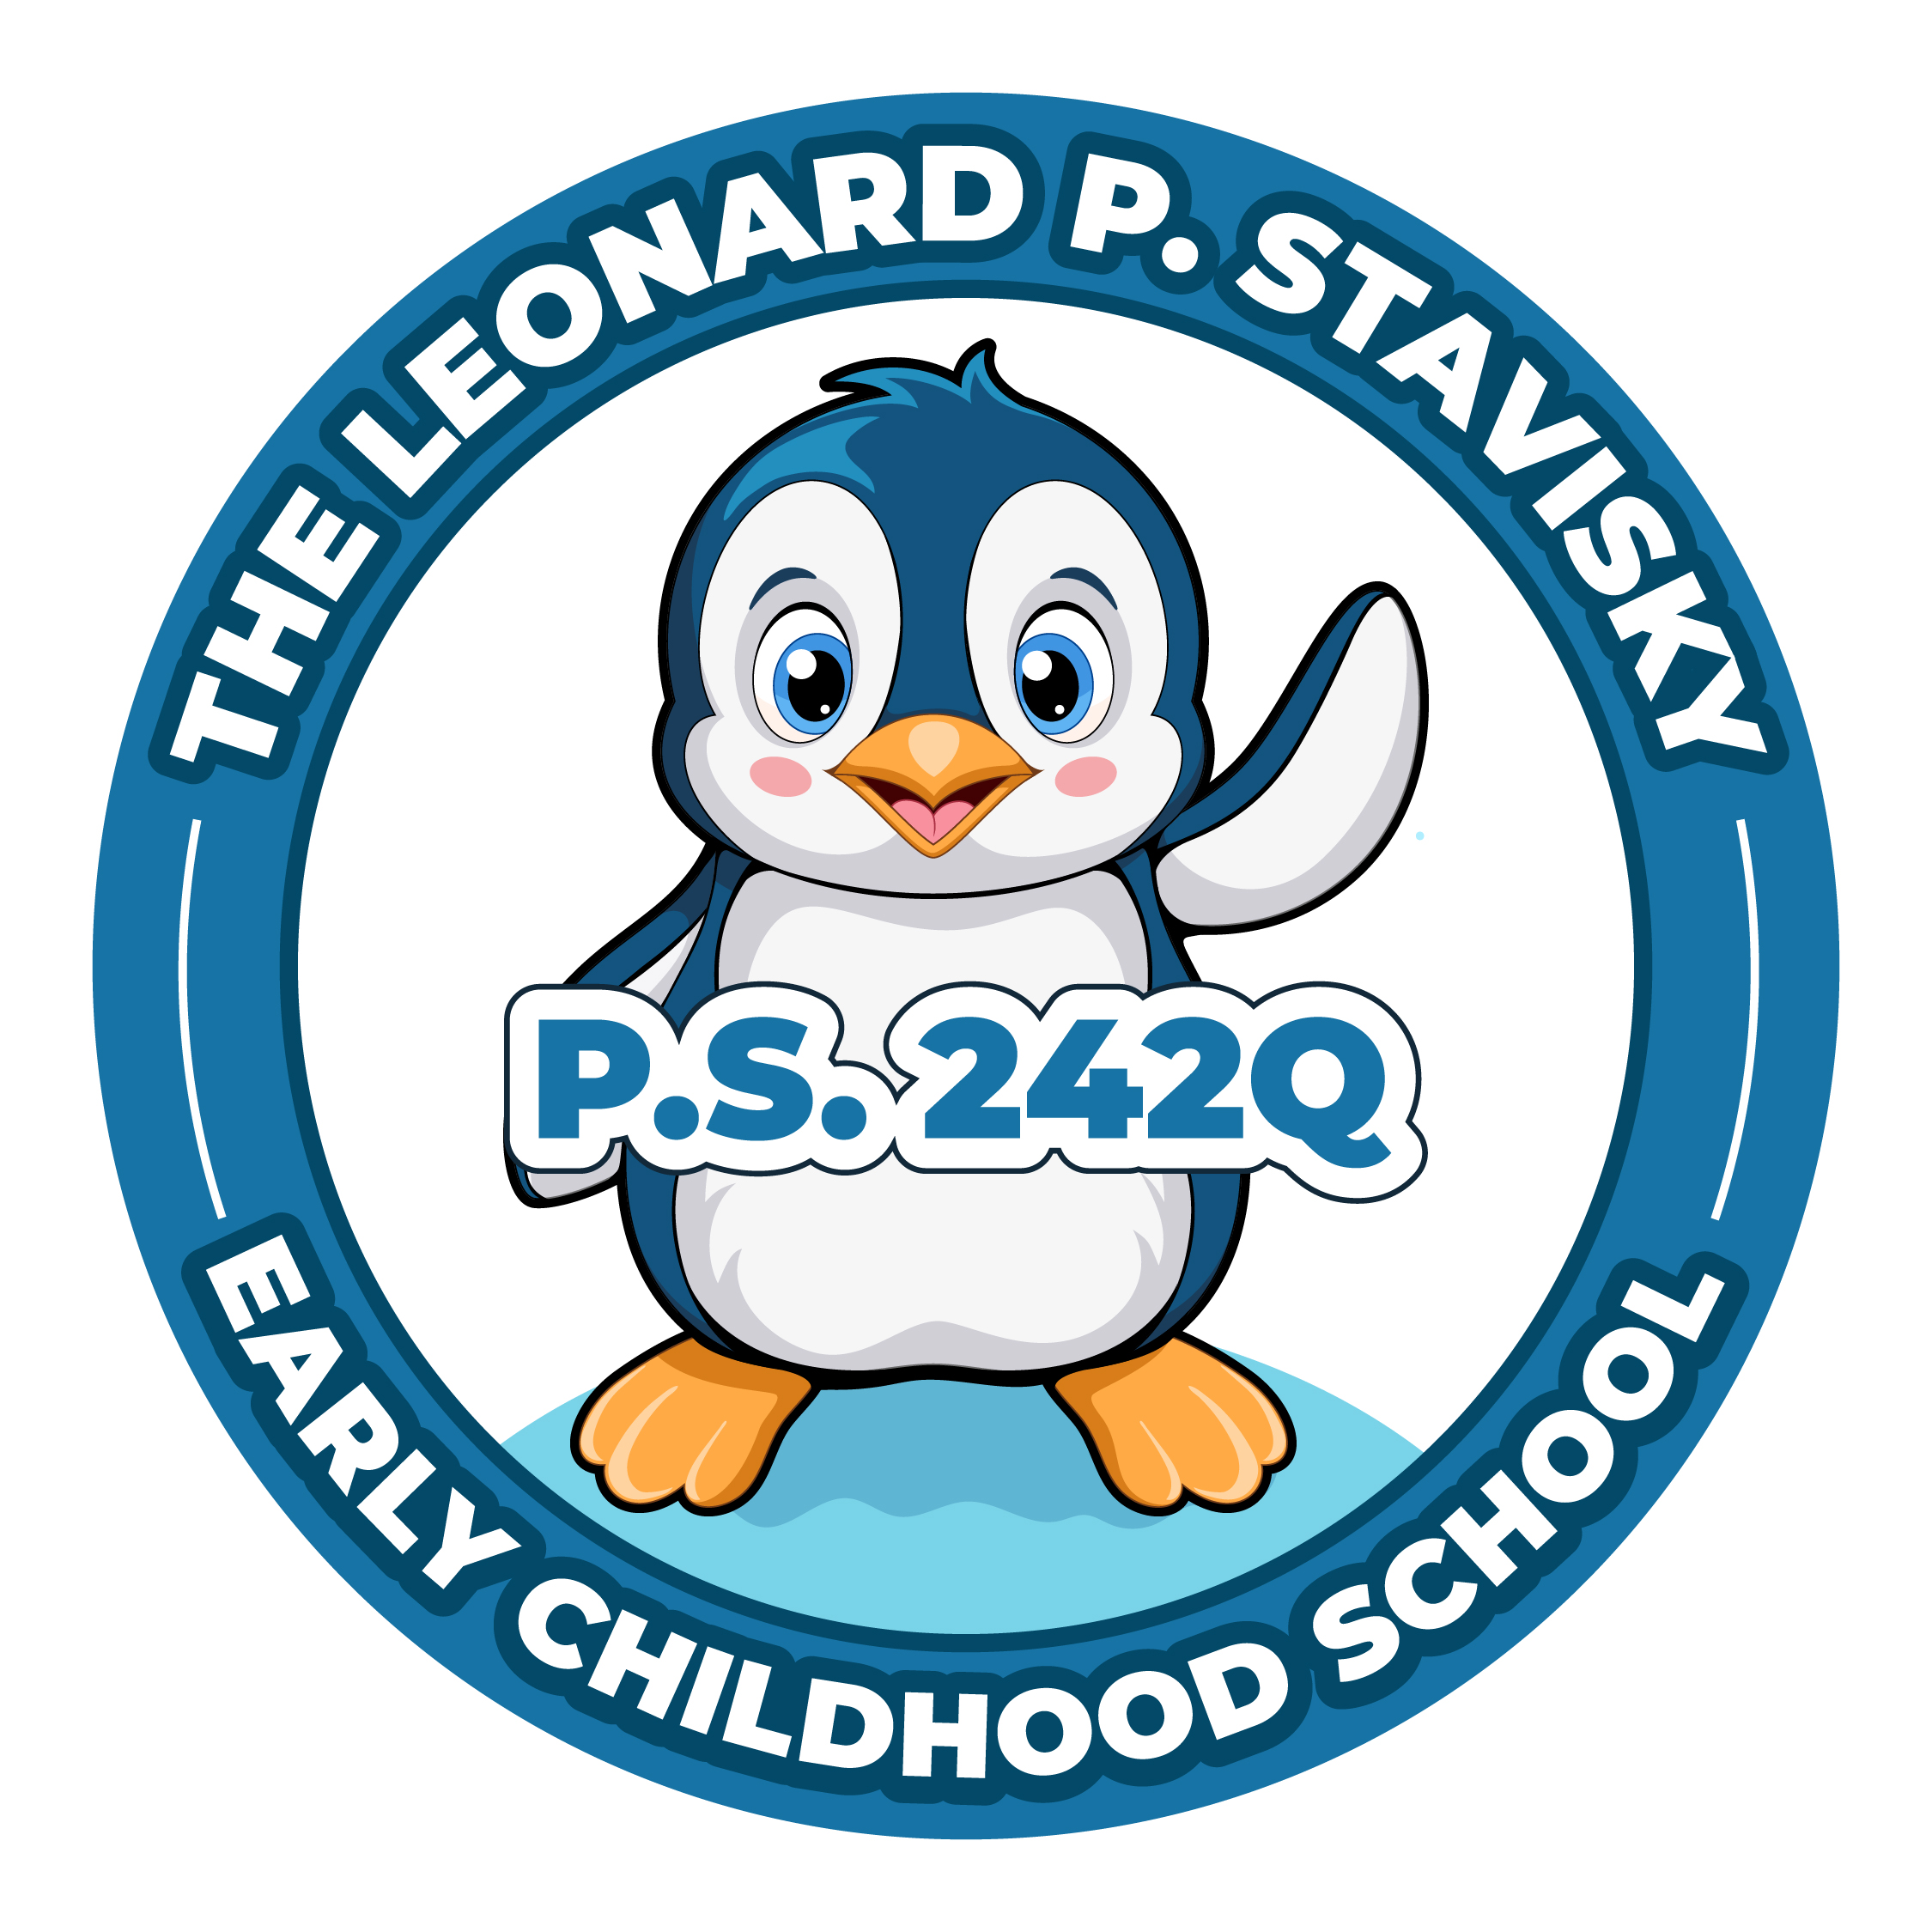
29-66 137th Street, Flushing, NY 11354
Phone: 718.445.2902 Fax: 718.939.7751

Virtual PTA Meeting
Wednesday, October 11th, 2023
6 p.m.
This meeting will be held on Google Meet, where the captions are able to be translated. More information on how to do that will be sent out. A link for the meeting will be posted the day of.

Updated Agenda

- Call to Order
- President’s Report
Bylaws Change
Volunteer List
Fall Picture Day
Fall Book Fair
Pumpkin patch/Character Parade
Fall Festival
School Store
- Treasurer’s Report
- Principal’s Report
- New Business
- Adjournment
- Title 1 PAC Chairperson Election

