The Leonard P. Stavisky Early Childhood School
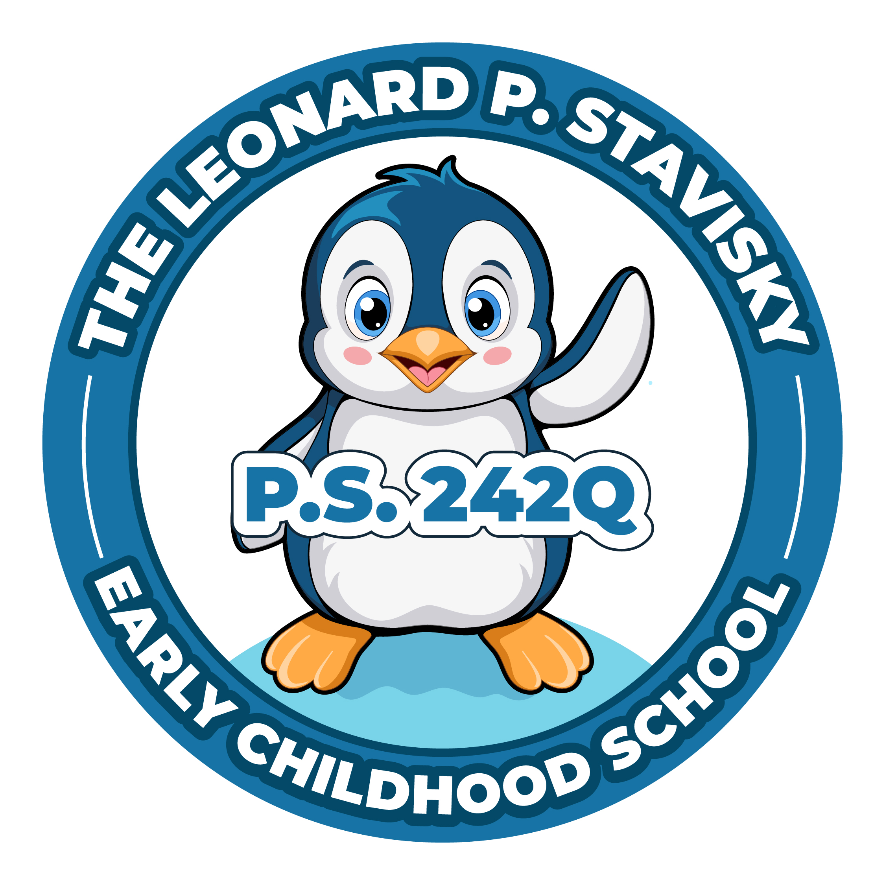
29-66 137th Street, Flushing, NY 11354
Phone: 718.445.2902 Fax: 718.939.7751

Virtual PTA Meeting
Thursday, November 21st, 2023
6:30 p.m.
This meeting will be held on Zoom, where the captions are able to be translated. More information on how to do that is listed after the agenda.

Updated Agenda

- Call to Order
- President’s Report
School Store
Donation Envelopes
- Treasurer’s Report
December Popcorn & Pajamas Budget
Holiday Goodie Bags Budget
- Principal’s Report
- New Business
- Adjournment

- Next to the Show Captions button, click the up caret button ..
- Under the Translate to section of the menu, click on the language you want the captions translated to.
Click the More option to see more available languages.
Once a different language is chosen, the captions will be generated and translated into that language for you. Other participants can choose a language for their captions independently of your chosen language.
Note: Choice of Translate to language will be saved and applied to future meetings.

