The Leonard P. Stavisky Early Childhood School
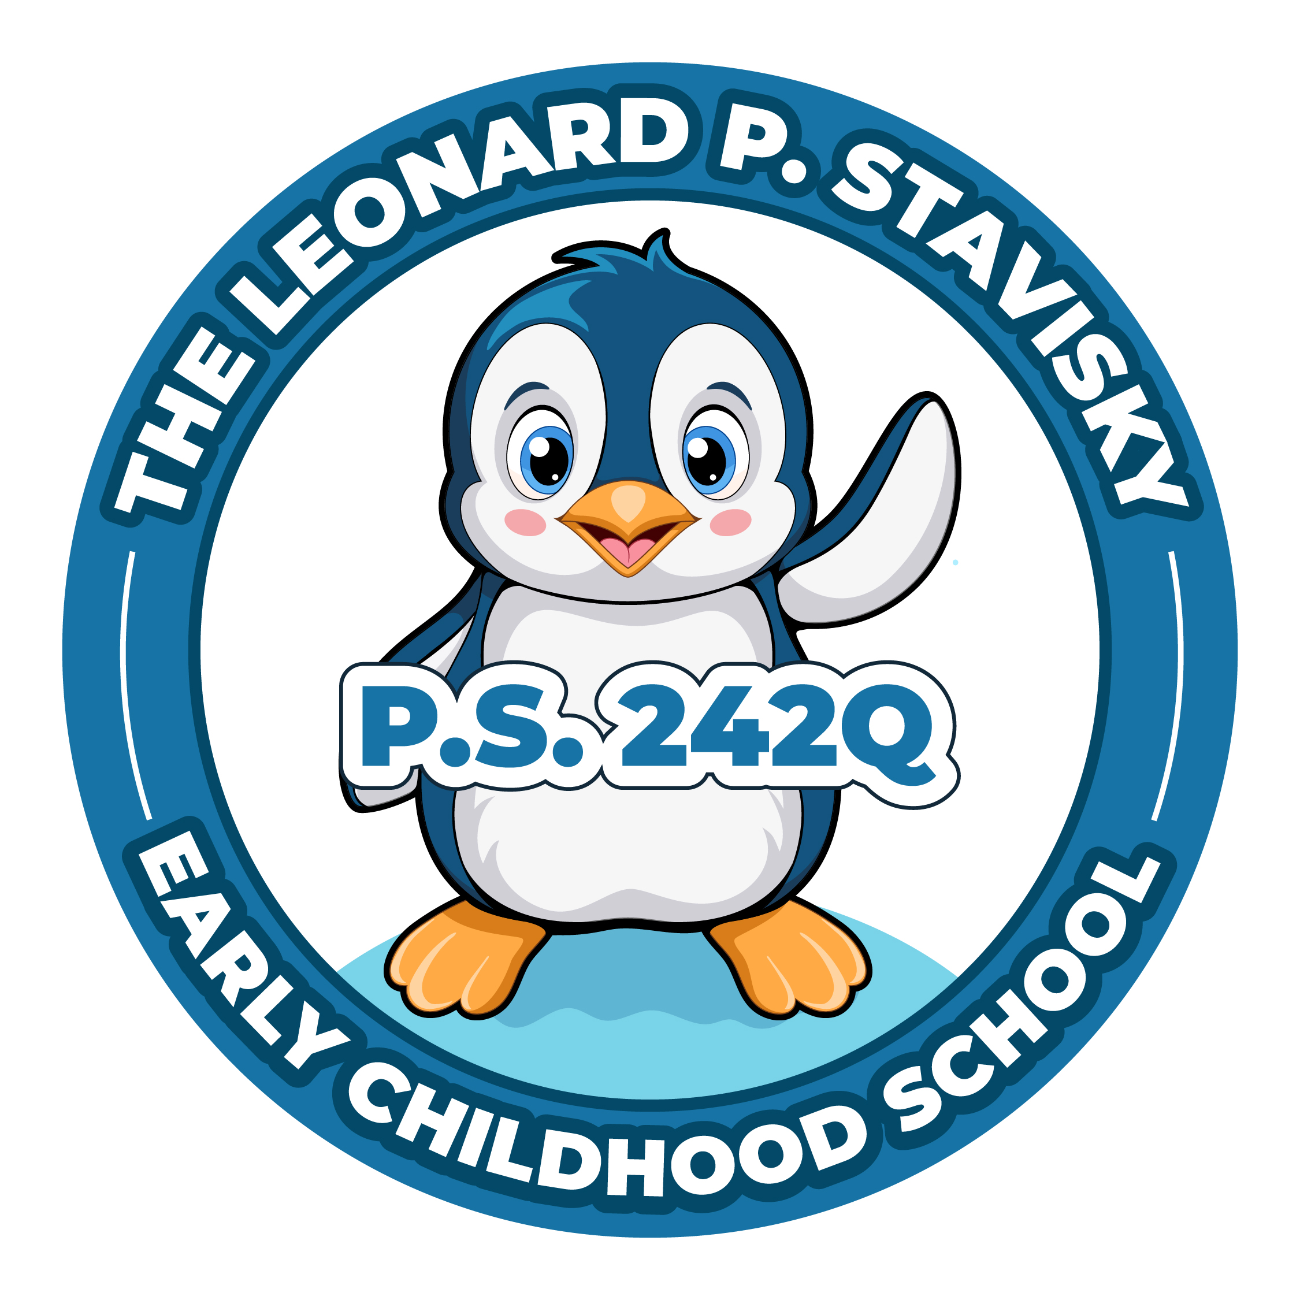
29-66 137th Street, Flushing, NY 11354
Phone: 718.445.2902 Fax: 718.939.7751

Virtual PTA Meeting
Thursday, January 18th, 2024
6pm

Updated Agenda
- Call to Order
- President’s Report
Graduation Picture Day 1/30
Senior Trip – Artistic Stitch 5/24
In-person Meetings
- Treasurer’s Report
Valentine’s Goodie Bag Budget
Valentine’s Popcorn & Pajamas Budget
Ice Cream Social Budget (June)
- Principal’s Report
- New Business
- Adjournment

