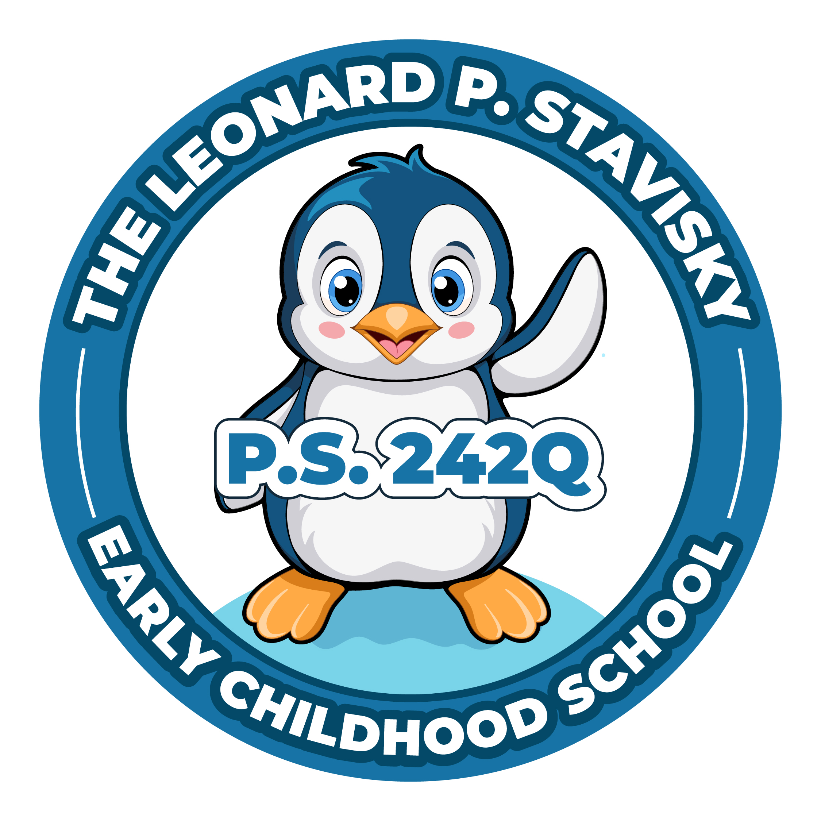
The Leonard P. Stavisky Early Childhood School
29-66 137th Street, Flushing, NY 11354
Phone: 718.445.2902 Fax: 718.939.7751

PTA MEETING—Monday, February 12th, 2024
Meeting called to Order @ 6:08pm
Approval of Minutes- Did not meet quorum, could not approve minutes.

Principal’s Report – Ms. Jill
- Tomorrow will be a remote learning day.
- All students are invited to go onto their Google classroom; all classes will have time working live with their teachers.
- The students will also have work to do outside of the live sessions.
- In morning by 8:45am the teacher will have posted on the Google classroom what the scope of the day looks like.
- On your child’s google classroom there’s an area where they can join a meet.
- (Shared screen to demonstrate how to access meet on Google classroom.)
- For students grade K- 3, they will have an opportunity during the day to join a cluster teacher’s class at their specified time.
- They can go to technology, PE, art, or science.
- We wanted to give the kids some choice for tomorrow and also an opportunity to see their classmates from previous years.
- If you have any problems connecting, make sure that you are in touch with the teacher via ParentSquare.
- Please be patient; know that he or she is also teaching the class.
- You can also reach out to Mrs. DiPiano; her contact info is in the ParentSquare message.
- Friday we are inviting parents in to help us with a lantern festival craft.
- If your child/children’s teacher hasn’t reached out yet, please reach out to them in regards to helping out that day.
- We also have the 2nd grade Mr. Alastair show Friday as well.
- Next week we’re off for midwinter recess.
- The week after we come back is parent-teacher conference, report cards will be going home March 6th.
- I encourage you to review the report cards and engage in a discussion with your child’s teacher about progress and ways to help.
- We have a few workshops coming up in March; a nutrition workshop and a positive parenting workshop.
- We’ve been doing lots of walkthroughs through the classrooms and see lots of elements of kids improving their literacy skills.
- You may notice at home they’re using some hand motions while they’re chopping up, decoding and creating words.
- That’s part of our Haggerty program.
- We’re also doing a lot of work in Fundations with letter sounds and their association; the sounds associated with the letters.
- We are using this in our program HMH (reading), as well as our other content areas such as math, social studies, science, the arts, physical education, and technology.
- If you have any questions, feel free to reach out to me.
- It was so wonderful to spend time with the families yesterday at Flushing Lunar New Year Parade.

Treasurers Report – Afeesat
- (Didn’t vote on any budget items; did not meet quorum.)
President’s Report - Chavaughn
- I want to thank all the families that joined us for popcorn and pajamas this past Friday, it went very well with our new seating arrangement.
- The graduation picture proofs for Pre-k, kindergarten and 3rd grade should be arriving by the end of the week.
- Readthon starts March 11th – March 25th, with more information to follow.
- As of right now, I’m going to hold off on voting on the bylaws and any budget items until the next meeting.
- If there’s any new business or questions, feel free to unmute or type it in the chat.
New Business
- Ms. Jill – I want to give a very special thank you to the Lunar New Year Planning committee. The put together so many of the events this past week. We do have a few other events coming up for the students; one of them being Wednesday. The students will be invited to us chopsticks to eat their lunch with.
Meeting adjourned at 6:21pm.

