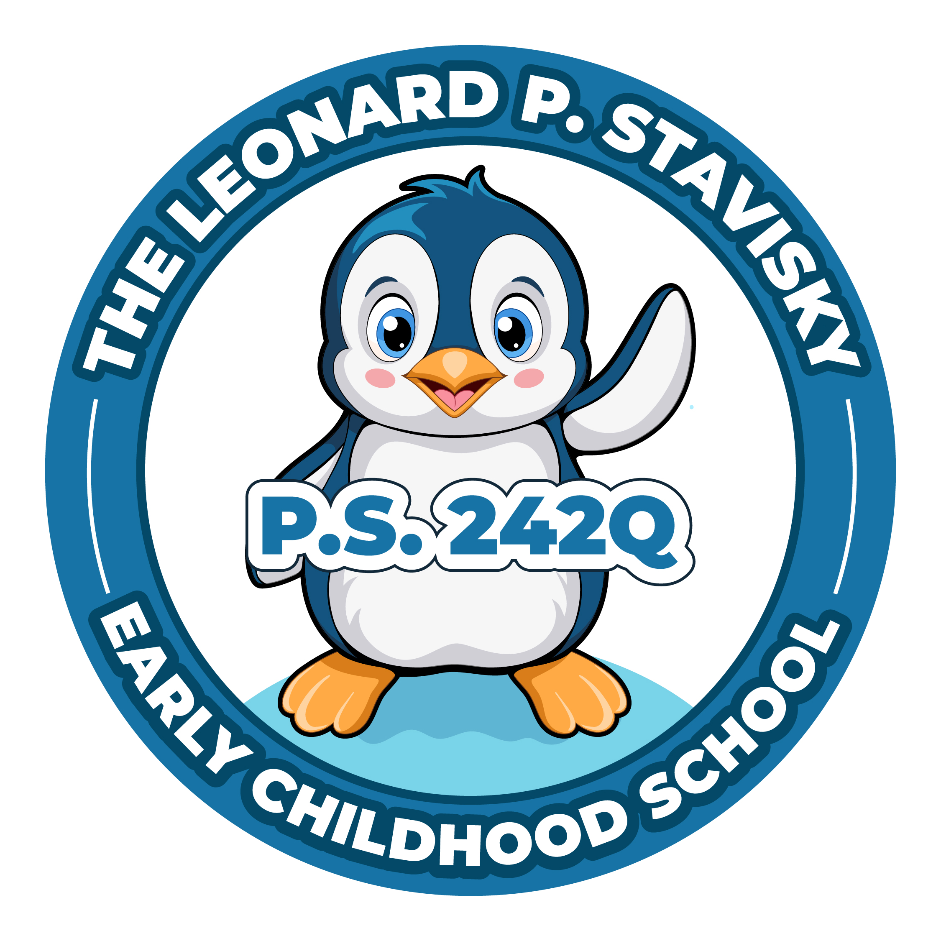
The Leonard P. Stavisky Early Childhood School
29-66 137th Street, Flushing, NY 11354
Phone: 718.445.2902 Fax: 718.939.7751

PTA MEETING--Wednesday, December 13th, 2023
Meeting called to Order @ 10:10am
Approval of Minutes- Record of the minutes approved.

Presidents Report - Chavaughn
- Polar Express night went well
- Holiday goodie bags will be handed out next week
- January 30th is graduation picture day for PK, K & 3rd grade (cap&gown only)
Treasurers Report – Afeesat
- Not able to access report, will share next meeting
Principal’s Report – Ms. Jill
- Safety concerns with student behavior at popcorn and pajamas
- Running around during event, need to be supervised by parents at PTA events
- What should our actions be in this circumstance?
--Parent support from administration
--Ask someone to leave if not making safe choices
--Student may not be allowed to attend future events if asked to leave
--New guidelines will be set going forward
- Winter Wonderland will be January 24th during school hours for all students
- December 20th Lunar New Year planning committee meeting; link will be posted on Parent Square
- June – International Night might be moved to May
- Blue Ribbon celebration went well
- December 22nd will be a day of fun/relaxed instructional approach in classrooms

Meeting adjourned at 10:35am.

